**A**

***PROJECT REPORT***

*on*

**GITAVERSE**

*Submitted in partial fulfilment of the requirements for the degree of*

**BACHELOR OF TECHNOLOGY**



Session: - 2024

Under Guidance of

Mr. Aaditya Maheshwari Assistant Professor

Computer Science & Engineering

Submitted by

Anurag Salvi (20ETCCS008) Bhanushree Chundawat (20ETCCS016) Deepanshu Kumawat (20ETCCS026) Himanshu Joshi (20ETCCS053)

Monish Soni (20ETCCS075)

Yash Kumar Gupta (20ETCCS117)

**DEPARTMENT OF COMPUTER SCIENCE AND ENGINEERING TECHNO INDIA NJR INSTITUTE OF TECHNOLOGY, UDAIPUR-313001 2024**

**A**

***PROJECT REPORT***

*on*

**GITAVERSE**

*Submitted in partial fulfilment of the requirements for the degree of*

**BACHELOR OF TECHNOLOGY**



**Session: - 2024**

Under Guidance of

Mr. Aaditya Maheshwari Assistant Professor

Computer Science & Engineering

Submitted by

Anurag Salvi (20ETCCS008) Bhanushree Chundawat (20ETCCS016) Deepanshu Kumawat (20ETCCS026) Himanshu Joshi (20ETCCS053)

Monish Soni (20ETCCS075)

Yash Kumar Gupta (20ETCCS117) 8th Sem (CSE)

**DEPARTMENT OF COMPUTER SCIENCE AND ENGINEERING TECHNO INDIA NJR INSTITUTE OF TECHNOLOGY, UDAIPUR-313001 2024**



Department of Computer Science and Engineering Techno India NJR Institute of Technology, Udaipur-313001

## Certificate

This is to certify that project work titled **“GITAVERSE”** by **Anurag Salvi** was successfully carried out in the Department of Computer Science and Engineering, TINJRIT and the report is approved for submission in the partial fulfillment of the requirements for award of degree of Bachelor of Technology in Computer Science and Engineering.

Mr. Aaditya Maheshwari Dr. Rimpy Bishnoi

Assistant Professor Professor and HOD

Computer Science & Engineering Dept. of CSE TINJRIT, Udaipur

Date Date



Department of Computer Science and Engineering Techno India NJR Institute of Technology, Udaipur-313001

## Certificate

This is to certify that project work titled **“GITAVERSE”** by **Bhanushree Chundawat** was successfully carried out in the Department of Computer Science and Engineering, TINJRIT and the report is approved for submission in the partial fulfillment of the requirements for award of degree of Bachelor of Technology in Computer Science and Engineering.

Mr. Aaditya Maheshwari Dr. Rimpy Bishnoi

Assistant Professor Professor and HOD

Computer Science & Engineering Dept. of CSE TINJRIT, Udaipur

Date Date



Department of Computer Science and Engineering Techno India NJR Institute of Technology, Udaipur-313001

## Certificate

This is to certify that project work titled **“GITAVERSE”** by **Deepanshu Kumawat** was successfully carried out in the Department of Computer Science and Engineering, TINJRIT and the report is approved for submission in the partial fulfillment of the requirements for award of degree of Bachelor of Technology in Computer Science and Engineering.

Mr. Aaditya Maheshwari Dr. Rimpy Bishnoi

Assistant Professor Professor and HOD

Computer Science & Engineering Dept. of CSE TINJRIT, Udaipur

Date Date



Department of Computer Science and Engineering Techno India NJR Institute of Technology, Udaipur-313001

## Certificate

This is to certify that project work titled **“GITAVERSE”** by **Himanshu Joshi** was successfully carried out in the Department of Computer Science and Engineering, TINJRIT and the report is approved for submission in the partial fulfillment of the requirements for award of degree of Bachelor of Technology in Computer Science and Engineering.

Mr. Aaditya Maheshwari Dr. Rimpy Bishnoi

Assistant Professor Professor and HOD

Computer Science & Engineering Dept. of CSE TINJRIT, Udaipur

Date Date



Department of Computer Science and Engineering Techno India NJR Institute of Technology, Udaipur-313001

## Certificate

This is to certify that project work titled **“GITAVERSE”** by **Monish Soni** was successfully carried out in the Department of Computer Science and Engineering, TINJRIT and the report is approved for submission in the partial fulfillment of the requirements for award of degree of Bachelor of Technology in Computer Science and Engineering.

Mr. Aaditya Maheshwari Dr. Rimpy Bishnoi

Assistant Professor Professor & HOD

Computer Science & Engineering Dept. of CSE TINJRIT, Udaipur

Date Date



Department of Computer Science and Engineering Techno India NJR Institute of Technology, Udaipur-313001

## Certificate

This is to certify that project work titled **“GITAVERSE”** by **Yash Kumar Gupta** was successfully carried out in the Department of Computer Science and Engineering, TINJRIT and the report is approved for submission in the partial fulfillment of the requirements for award of degree of Bachelor of Technology in Computer Science and Engineering.

Mr. Aaditya Maheshwari Dr. Rimpy Bishnoi

Assistant Professor Professor & HOD

Computer Science & Engineering Dept. of CSE TINJRIT, Udaipur

Date Date



Department of Computer Science and Engineering Techno India NJR Institute of Technology, Udaipur-313001

## Examiner Certificate

This is to certify that the following student **Anurag Salvi** of final year B.Tech. (Computer Science and Engineering), was examined for the project work titled

***“GITAVERSE”***

during the academic year 2023 – 2024 at Techno India NJR Institute of Technology, Udaipur

**Remarks:**

**Date:**

Signature Signature

(**Internal Examiner**) (**External Examiner**)

Name :- Name :-

Designation :- Designation:-

Department :- Department: -

Organization:- Organization:-



Department of Computer Science and Engineering Techno India NJR Institute of Technology, Udaipur-313001

## Examiner Certificate

This is to certify that the following student **Bhanushree Chundawat** of final year B.Tech. (Computer Science and Engineering), was examined for the project work titled

***“GITAVERSE”***

during the academic year 2023 – 2024 at Techno India NJR Institute of Technology, Udaipur

**Remarks:**

**Date:**

Signature Signature

(**Internal Examiner**) (**External Examiner**)

Name :- Name :-

Designation :- Designation:-

Department :- Department: -

Organization:- Organization:-



Department of Computer Science and Engineering Techno India NJR Institute of Technology, Udaipur-313001

## Examiner Certificate

This is to certify that the following student **Deepanshu Kumawat** of final year B.Tech. (Computer Science and Engineering), was examined for the project work titled

***“GITAVERSE”***

during the academic year 2023 – 2024 at Techno India NJR Institute of Technology, Udaipur

**Remarks:**

**Date:**

Signature Signature

(**Internal Examiner**) (**External Examiner**)

Name :- Name :-

Designation :- Designation:-

Department :- Department: -

Organization:- Organization:-



Department of Computer Science and Engineering Techno India NJR Institute of Technology, Udaipur-313001

## Examiner Certificate

This is to certify that the following student **Himanshu Joshi** of final year B.Tech. (Computer Science and Engineering), was examined for the project work titled

***“GITAVERSE”***

during the academic year 2023 – 2024 at Techno India NJR Institute of Technology, Udaipur

**Remarks:**

**Date:**

Signature Signature

(**Internal Examiner**) (**External Examiner**)

Name :- Name :-

Designation :- Designation:-

Department :- Department: -

Organization:- Organization:-



Department of Computer Science and Engineering Techno India NJR Institute of Technology, Udaipur-313001

## Examiner Certificate

This is to certify that the following student **Monish Soni** of final year B.Tech. (Computer Science and Engineering), was examined for the project work titled

***“GITAVERSE”***

during the academic year 2023 – 2024 at Techno India NJR Institute of Technology, Udaipur

**Remarks:**

**Date:**

Signature Signature

(**Internal Examiner**) (**External Examiner**)

Name :- Name :-

Designation :- Designation:-

Department :- Department: -

Organization:- Organization:-



Department of Computer Science and Engineering Techno India NJR Institute of Technology, Udaipur-313001

## Examiner Certificate

This is to certify that the following student **Yash Kumar Gupta** of final year B.Tech. (Computer Science and Engineering), was examined for the project work titled

***“GITAVERSE”***

during the academic year 2023 – 2024 at Techno India NJR Institute of Technology, Udaipur

**Remarks:**

**Date:**

Signature Signature

(**Internal Examiner**) (**External Examiner**)

Name :- Name :-

Designation :- Designation:-

Department :- Department: -

Organization:- Organization:-

## Preface

GitaVerse: a new platform designed to bridge the gap between the expertise of the ancient Vedas and the demands of modern life. This document is a complete examination of our efforts to combine undying coaching with modern-day demanding situations.

This report outlines our goals, strategies, and findings as we are searching for to cope with the intersection of Vedic knowledge and its effect on well-being. From a survey of the applicable literature to an evaluation of present meetings, we delve into the demanding situations and opportunities of this endeavor.

We also took reference from an excellent study hosted by the National Center for Biotechnology Information (NCBI) presents valuable insights into the undying relevance of Vedic teachings and their capability to enrich modern lives. This looks at explores nonsecular philosophy and sensible applications, demonstrating how those historical ideas seamlessly integrate into our daily lives. Access the have a look at here for further exploration.

Join us on this journey as we discover the structure of Gita verses, delve into software issues, and discuss the significance of bridging the gap among historical knowledge and current life. Together, allow us to pave the way for a greater harmonious and vibrant destiny.

**ACKNOWLEDGMENT**

We take this opportunity to record our sincere thanks to all who helped us to successfully complete this work. Firstly, we are grateful to our **supervisor Mr. Aaditya Maheshwari** for his invaluable guidance and constant encouragement, support and most importantly for giving us the opportunity to carry out this work.

We would like to express our deepest sense of gratitude and humble regards to our **Head of Department Dr. Rimpy Bishnoi** for giving invariable encouragement in our endeavors and providing necessary facility for the same. Also, a sincere thanks to all faculty members of CSE, TINJRIT for their help in the project directly or indirectly.

Finally, we would like to thank my friends for their support and discussions that have proved very valuable for us. We are indebted to our parents for providing constant support, love and encouragement. We thank them for the sacrifices they made so that we could grow up in a learning environment. They have always stood by us in everything we have done, providing constant support, encouragement and love.

**Anurag Salvi (20ETCCS008) Bhanushree Chundawat (20ETCCS016) Deepanshu Kumawat (20ETCCS026) Himanshu Joshi (20ETCCS053) Monish Soni (20ETCCS075)**

**Yash Kumar Gupta (20ETCCS117)**

## CONTENTS

|  |  |  |  |  |
| --- | --- | --- | --- | --- |
|  | **Certificate** | | i-vi | |
|  | **Examiner Certificate** | | vii-xii | |
| **Preface** | | | xiii | |
| **Acknowledgement** | | | xiv | |
| **List of Figures** | | | xviii | |
| **List of Tables** | | | xix | |
| **List of Abbreviation/Symbols** | | | xx | |
| **Chapter 1** INTRODUCTION | | | 1 | |
| 1.1 Background and Motivation | | | 1 | |
| 1.2 Objectives of the Project | | | 1 | |
| 1.3 Overview of the Problem Statement | | | 2 | |
| **Chapter 2** LITERAURE REVIEW | | | 3 | |
| 2.1 Survey of Relevant Literature on Vedic Wisdom and Its Integration with Modern Life | | | 3 | |
| 2.2 Analysis of Existing Platforms and Initiatives in the Field | | | 3 | |
| **Chapter 3** PROBLEM STATEMENT | | 5 | |
| 3.1 Detailed explanation of the Classification of Vedic Wisdom: One must go into the depths | | 5 | |
| 3.2 Impact on Daily Life Routines and Well-being | | 5 | |
| 3.3 Evaluation of Challenges Faced by Existing Platforms | | 6 | |
| **Chapter 4** OBJECTIVE AND SCOPE | | 8 | |
| 4.1 Specific Goals of the Project | | 8 | |
| 4.1.1 Integration of Vedic Wisdom with Modern Life | | 8 | |
| 4.1.2 Development of Online Educational Resource | | 8 | |
| 4.1.3 Promotion of Personal Growth and Well Being | | 8 | |
| 4.1.4 Cultivation of Global Community | | 8 | |
| 4.2 Scope and Boundaries of the Work | | 9 | |
| 4.2.1 Online Platform Development | | 9 | |
| 4.2.2 Content Creation and Curation | | 9 | |
| 4.2.3 Community Building and Engagement | | 9 | |
| 4.2.4 Continuous Improvement and Evolution | | 9 | |
| **Chapter 5** METHODOLOGY | | 10 | |
| 5.1 detailed Explanation of Development Process | | 10 | |
| 5.1.1 Conceptualization and Planning | | 10 | |
| 5.1.2 Designing and Prototyping | | 10 | |
| 5.1.3 Testing and Quality Assurrance | | 10 | |
| 5.1.4 Monitoring and Maintenance | | 11 | |
| 5.2 Technologies used and Justification for their Selection | | 11 | |
| **Chapter 6** SYSTEM ARCHITECTURE | | 13 | |
| 6.1 Overview of the Architecture of GitaVerse Platform | | 13 | |
| 6.2 Description of Frontend, Backend, and Database Components | | 13 | |
| 6.2.1 Frontend Component | | 13 | |
| 6.2.2 Backend Component | | 13 | |
| 6.2.3 Database Component | | 14 | |
| **Chapter 7** IMPLEMENTATION DETAILS | | 15 | |
| 7.1 Data Flow Diagram | | 15 | |
| 7.2 Development Environment Setup | | 16 | |
| 7.3 Data Models and Database Design | | 16 | |
| **Chapter 8** RESULT AND EVALUATION | | 17 | |
| 8.1 Presentation of Project Outcomes | | 17 | |
| 8.2 Interpretation of Results | | 17 | |
| 8.3 Limitations | | 18 | |
| 8.4 The Future Scope of the Project | | 18 | |
| **Chapter 9** CONCLUSION | | 19 | |
| **APPENDICES** | | 19 | |

**List of Figures**

|  |  |  |
| --- | --- | --- |
| Fig No. | Title | Page No. |
| Fig 1.3.1 | Courses | 2 |
| Fig 3.3.1 | Registration Pop-up Form | 6 |
| Fig 3.3.2 | Landing Page | 7 |
| Fig 5.1.3.1 | Figma Prototype | 11 |
| Fig 7.1.1 | GitaVerse - DFD | 15 |
| Fig 7.3.1 | GItaVerse - (ER Diagram) | 16 |
| Fig 8.1.1 | Project Outcomes | 17 |

**LIST OF TABLES**

|  |  |  |
| --- | --- | --- |
| **Table No.** | **Title** | **Page No.** |
| Table 5-1 | Technology Stack | 12 |

|  |  |
| --- | --- |
| NCBI | National Center for biotechnology information |
| UI | User Interface |
| UX | User Experience |
| UAT | User Acceptance testing |
| SQL | Structure Query Language |
| RBAC | Role Based Access Control |
| API | Application Programming Interface |
| DFD | Data Flow Diagram |
| ER | Entity Relationship |

## List of Abbreviations/ Symbols

**CHAPTER 1**

**INTRODUCTION**

The timeless pursuit of spiritual fulfillment and holistic living has been an enduring facet of human existence. In today's fast-paced world, amidst the hustle and bustle of modern life, many individuals yearn for a deeper connection to ancient wisdom and profound philosophies. GitaVerse emerges within this context, serving as a guiding light that bridges the profundity of Vedic wisdom with the realities of contemporary life.

* 1. **Background and Motivation**

GitaVerse finds its roots in the rich tapestry of ancient Indian scriptures, particularly the Bhagavad Gita. It stems from a profound reverence for the timeless wisdom encapsulated within these sacred texts. As society grapples with increasing stress and disconnection, there is a pressing need to revive and recontextualize the insights offered by Vedic teachings. GitaVerse is motivated by a sincere desire to make these teachings accessible to individuals from all backgrounds, transcending cultural and geographical boundaries.  
  
**1.2 Objectives of the Project**

Objective:

● Integrate Bhagavad Gita's teachings with science.

● Offer courses on Understanding God from Science, Like - The science of the soul, and Vedic solutions.

● Provide a holistic journey into spirituality through science-backed insights.

Scope:

● Global accessibility to science + scripture courses.

● Thematic Introduction to Bhagavad Gita for practical application.

● E-Gurukul for Kids: Moral development, yoga, and meditation inspired by the

Bhagavad Gita.

● Foster cultural awareness and parental involvement for holistic growth in children.

**1.3 Overview of the Problem Statement**

In today's world, characterized by constant distractions and material pursuits, there is a profound disconnect from the timeless principles espoused by Vedic wisdom. This disconnects manifests in various forms, including existential angst and societal discord. Existing platforms often fail to address the diverse needs of modern individuals, exacerbating the gap between ancient wisdom and contemporary reality. GitaVerse aims to address these challenges by offering a holistic solution that harmonizes ancient wisdom with modern sensibilities, fostering a culture of mindfulness, compassion, and inner harmony.

**Main Courses on GitaVerse:**

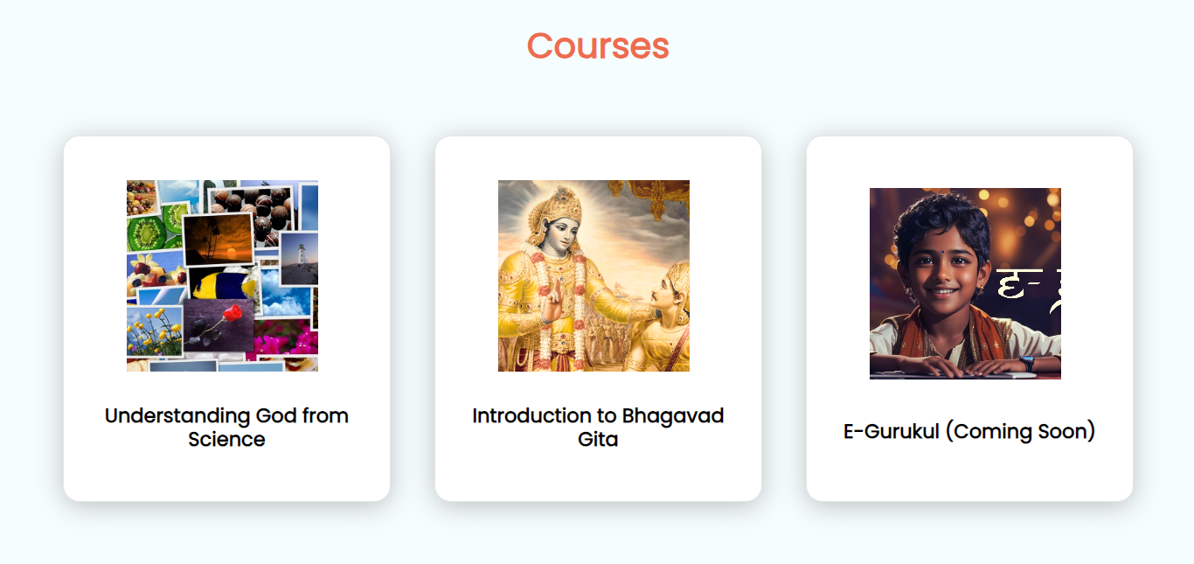

**Figure 1.3.1 Courses**

**CHAPTER 2**

**LITERATURE REVIEW**

**2.1 Survey of Relevant Literature on Vedic Wisdom and Its Integration with Modern Life:**

In our exploration of integrating ancient Vedic wisdom into modern life, a significant study hosted by the **(NCBI)** stands out. This study delves into the enduring relevance of Vedic teachings, offering profound insights into their potential to enrich and transform modern lives. Covering spiritual philosophy and practical applications, it navigates the intricate landscape of Vedic wisdom, illustrating how these age-old principles seamlessly integrate into our daily lives.   
  
Our project, GitaVerse, stands as a testament to the enduring relevance of these ancient texts in navigating the complexities of modern life. Through our platform, we aim to bridge the gap between ancient wisdom and contemporary challenges, offering users a pathway to personal growth and spiritual enrichment.  
  
In parallel, contemporary authors and thought leaders have contributed to this discourse by exploring the practical applications of Vedic principles in everyday life. Through insightful analyses and practical guidance, they illuminate the relevance of Vedic teachings in addressing contemporary issues such as mindfulness, holistic wellness, ethical leadership, and sustainable living.  
  
**2.2 Analysis of Existing Platforms and Initiatives in the Field**

In parallel, contemporary literature has emerged, shedding light on the integration of Vedic principles with the complexities of modern life. Platforms such as **GitaQuest,** **Veducation World**, and **Save Values** have emerged as pioneers in this endeavor, offering innovative approaches to bridging the gap between ancient wisdom and contemporary challenges.

An examination of existing platforms and initiatives reveals a vibrant ecosystem of efforts aimed at integrating Vedic wisdom into modern life. Within this landscape, GitaVerse emerges as a beacon of light, offering users immersive learning experiences and opportunities for dialogue and reflection.  
  
By leveraging technology and community engagement, GitaVerse provides users with access to a wealth of educational resources, workshops, and events centered around Vedic philosophy and its practical applications. Through curated content and personalized experiences, our platform seeks to make Vedic knowledge accessible and relevant to individuals from all walks of life.  
  
In conclusion, GitaVerse exemplifies the diversity of approaches to integrating Vedic wisdom into modern life. Through our platform, we strive to empower individuals to lead lives imbued with meaning, purpose, and resilience, guided by the timeless wisdom of the ancients.

**CHAPTER 3**

**PROBLEM STATEMENT**

In a fast-paced world, there's a profound disconnect from Vedic wisdom, leading to challenges in character development and holistic well-being. Existing platforms lack a structured approach to impart transformative knowledge from scriptures, hindering individuals from merging ancient wisdom with contemporary life. GitaVerse aims to bridge this gap, offering accessible online sessions to guide individuals toward a positive paradigm shift, fostering a more balanced and purposeful life through this platform.

**Identified Problem**: Disconnection from Vedic wisdom impacting daily life routines and individual well-being.

**Challenges in Daily Life Routine**: Addressing specific challenges individuals face in their day-to-day lives.

**3.1 Detailed explanation of the Classification of Vedic Wisdom: One must go into the depths**

The explosiveness of Vedic wisdom opens up incredibly dramatic contrasts, juxtaposing the deep spiritual principles of antiquity with the ceaseless flow of modern social norms. Between the whirlwind of modernity, individuals are swallowed up by the transcendental wisdom that is largely absent from the sacred texts of the Bhagavad Gita and the Upanishads. This strategy is due to cultural distractions and disturbing waves of technological progress that together in the chaos. It is in this incredible mosaic that a platform like the GitaVerse emerges as a shining beacon, seeking to move the essence of transformative wisdom from the canonical books of history to the means of enlightenment they can be accessed.

**3.2 Impact on Daily Life Routines and Well-being**

The disconnection from Vedic wisdom has far-reaching implications for daily life routines and overall well-being. Without access to spiritual guidance and ethical principles, individuals may struggle to cultivate resilience, inner peace, and purpose in their lives. The absence of a moral compass rooted in Vedic teachings can lead to ethical dilemmas, existential crises, and a sense of disconnection from oneself and others.

Furthermore, the disconnect from Vedic wisdom exacerbates stress, anxiety, and mental health issues prevalent in modern society. Individuals may grapple with feelings of emptiness, dissatisfaction, and spiritual malaise, as they search for meaning and fulfilment in a world characterized by materialism and superficiality.

**3.3 Evaluation of Challenges Faced by Existing Platforms**

Existing platforms aiming to address the disconnection from Vedic wisdom encounter various challenges in effectively bridging the gap between ancient teachings and contemporary life. These challenges include:

**Lack of structured approach**: Many platforms lack a systematic framework for imparting transformative knowledge from scriptures, hindering individuals from integrating ancient wisdom into their daily lives.

**Accessibility barriers**: Language barriers, cultural biases, and technological constraints limit the accessibility of existing platforms, thereby restricting their reach and impact.

**Absence of personalized guidance**: Existing platforms often fail to provide personalized guidance and interactive learning experiences, hampering individuals' ability to engage deeply with the teachings and apply them practically in their lives.

**Resgistration Pop-up Form & Landing page:**

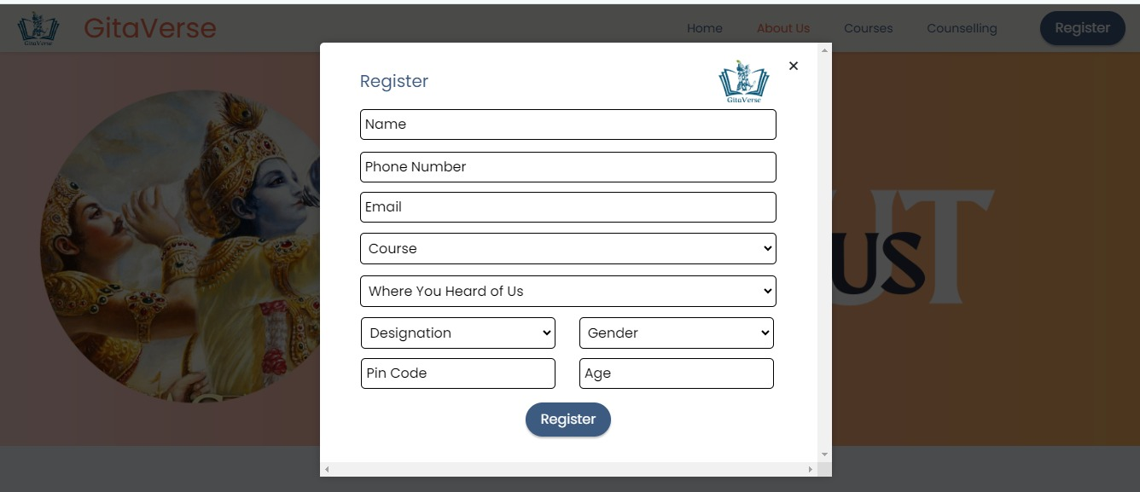

**Figure 3.3.1 Registration Pop-up form**

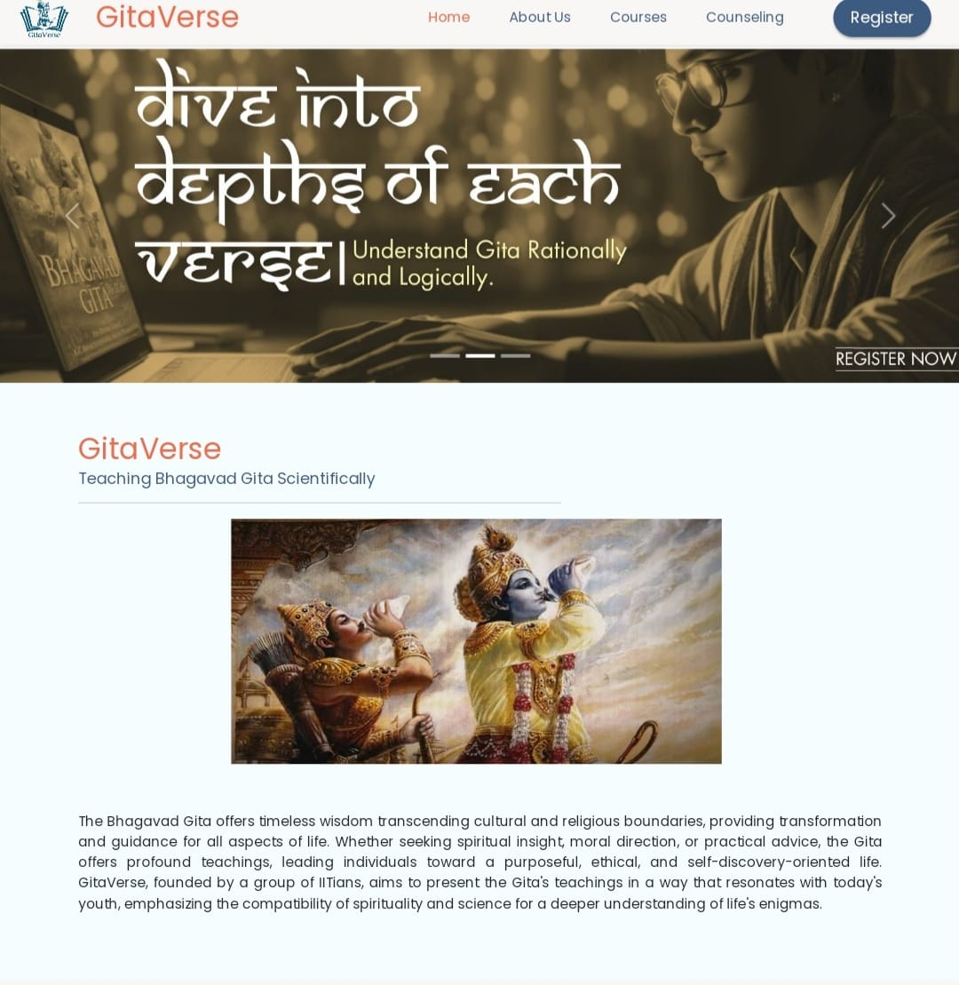

**Figure 3.3.2 Landing Page**

**CHAPTER 4**

**OBJECTIVE AND SCOPE**

The objective and scope section delineate the specific goals of the GitaVerse project and outline its scope and boundaries to provide a clear understanding of its aims and limitations.

**4.1 Specific Goals of the Project**

The primary goals of the GitaVerse project are as follows:

**4.1.1 Integration of Vedic Wisdom with Modern Life:**

* To bridge the gap between ancient Vedic wisdom, particularly from texts like the Bhagavad Gita, and modern life practices.
* To explore the relevance of Vedic principles in addressing contemporary challenges and fostering holistic well-being.

**4.1.2 Development of Online Educational Resources:**

* To develop a comprehensive platform offering online courses, resources, and interactive sessions on Vedic philosophy, spirituality, and practical applications.
* To provide structured learning experiences that enable individuals to deepen their understanding of Vedic teachings and apply them in their daily lives.

**4.1.3 Promotion of Personal Growth and Well-being:**

* To empower individuals to cultivate resilience, inner peace, and purpose through the integration of Vedic wisdom into their daily routines.
* To foster holistic well-being by addressing spiritual, mental, and emotional aspects of human existence.

**4.1.4 Cultivation of Global Community:**

* To create a vibrant online community of learners, practitioners, and experts dedicated to exploring Vedic wisdom and its application in modern life.
* To facilitate knowledge sharing, discussions, and collaborations that transcend geographical boundaries and cultural differences.

**4.2 Scope and Boundaries of the Work**

The scope of the GitaVerse project encompasses the following areas:

**4.2.1 Online Platform Development:**

* Development of a user-friendly online platform, including website and mobile application, to host educational resources, courses, and interactive sessions.
* Implementation of features such as video lectures, live webinars, discussion forums, and personalized guidance to enhance user engagement and learning outcomes.

**4.2.2 Content Creation and Curation:**

* Creation and curation of high-quality educational content, including course materials, articles, videos, and podcasts, grounded in Vedic wisdom and modern understanding.
* Collaboration with subject matter experts, scholars, and practitioners to ensure the accuracy, relevance, and accessibility of the content.

**4.2.3 Community Building and Engagement:**

* Establishment of online communities and social media channels to foster interactions, knowledge sharing, and collaboration among users.
* Organization of virtual events, workshops, and retreats to facilitate deeper learning experiences and personal connections within the community.

**4.2.4 Continuous Improvement and Evolution:**

* Commitment to ongoing refinement and enhancement of the platform and its offerings based on user feedback, technological advancements, and emerging trends.
* Exploration of partnerships, collaborations, and strategic alliances to expand the reach and impact of GitaVerse globally.

**CHAPTER 5**

**METHODOLOGY**

The methodology section outlines the detailed explanation of the development process adopted for GitaVerse and the technologies used along with the justification for their selection.

**5.1 Detailed Explanation of the Development Process**

The development process for GitaVerse follows a systematic approach aimed at creating a robust and user-friendly platform for integrating Vedic wisdom with modern life. The process consists of several key stages:

**5.1.1 Conceptualization and Planning:**

* The project begins with a thorough conceptualization phase where the goals, objectives, and scope of GitaVerse are defined.
* Detailed planning is carried out to identify the target audience, content requirements, features, and functionalities of the platform.

**5.1.2 Design and Prototyping:**

* The design phase focuses on creating the (UI) and (UX) design for GitaVerse.
* Prototypes are developed using tools like **Figma** to visualize the layout, navigation flow, and interactive elements of the platform.

**5.1.3 Testing and Quality Assurance:**

* Rigorous testing is conducted to identify and fix any bugs, errors, or inconsistencies in the platform.
* (UAT) is carried out to ensure that the platform meets the requirements and expectations of the target audience

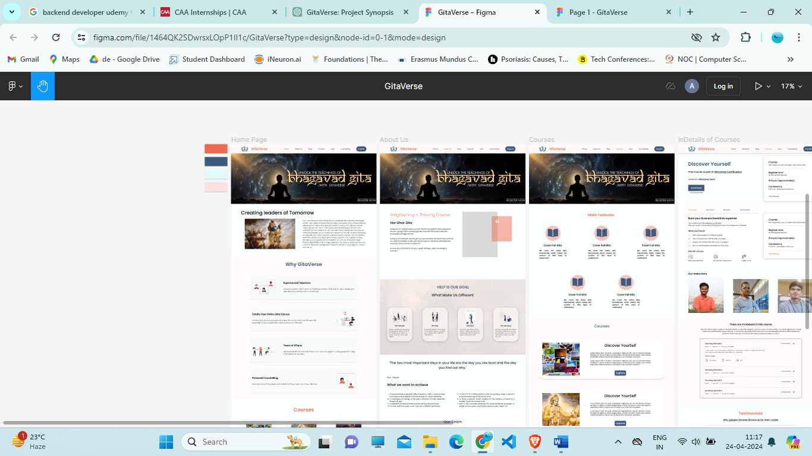

**Figure 5.1.3.1 Figma Prototype**

**5.1.4 Monitoring and Maintenance:**

* Continuous monitoring and maintenance are performed to ensure the stability, performance, and security of the platform.
* Regular updates and improvements are rolled out based on user feedback and emerging requirements.

**5.2 Technologies Used and Justification for Their Selection**

The technologies selected for GitaVerse have been chosen based on their suitability for achieving the project's goals, requirements, and technical considerations. The technologies used include:

* **Frontend: React JS**

Justification: React JS is chosen for its efficiency, flexibility, and component-based architecture, allowing for the development of interactive and responsive user interfaces.

* **Backend: Express JS, Node JS**

Justification: Express JS and Node JS are selected for their lightweight and scalable nature, facilitating the development of robust backend APIs and server-side logic.

* **Build & Tooling: Vite JS**

Justification: Vite JS is adopted for its fast and efficient build process, enabling rapid development iterations and seamless integration with other frontend and backend technologies.

* **Database: MongoDB**

Justification: MongoDB is chosen for its flexibility, scalability, and performance, making it suitable for storing and managing diverse data types and handling large volumes of data.

|  |  |
| --- | --- |
| **Frontend** | React JS |
| **Backend** | Express JS, Node JS |
| **Build & Tooling** | Vite JS |
| **Database** | MongoDB |

**Table 5-1 Technology Stack**

**CHAPTER 6**

**SYSTEM ARCHITECTURE**

The system architecture section provides an overview of the architecture of the GitaVerse platform, including descriptions of its frontend, backend, and database components.

**6.1 Overview of the Architecture of GitaVerse Platform**

The architecture of the GitaVerse platform is designed to be scalable, flexible, and efficient, providing users with a seamless and responsive experience. The platform follows a modern microservices architecture, which allows for modular development, easy scalability, and improved maintainability.

At its core, GitaVerse consists of three main components: the frontend, backend, and database. These components work together to deliver a cohesive and interactive platform for accessing Vedic wisdom and integrating it into modern life.

**6.2 Description of Frontend, Backend, and Database Components**

**6.2.1 Frontend Component:**

* The frontend component of GitaVerse is responsible for rendering the user interface (UI) and facilitating user interactions.
* Built using React JS, a popular JavaScript library for building user interfaces, the frontend provides a dynamic and responsive user experience.
* The frontend communicates with the backend through RESTful APIs to fetch data, process user requests, and update the UI accordingly.
* Key features of the frontend include intuitive navigation, interactive course materials, and personalized user profiles.

**6.2.2 Backend Component:**

* The backend component of GitaVerse serves as the core logic and functionality of the platform, handling user authentication, data processing, and business logic.
* Developed using Express JS and Node JS, the backend consists of modular services and APIs that interact with the frontend and database components.
* The backend implements security measures such as authentication tokens, (RBAC), and data encryption to ensure the confidentiality and integrity of user data.
* Additionally, the backend integrates with external services and APIs for functionalities such as payment processing, analytics, and content delivery.

**6.2.3 Database Component:**

* The database component of GitaVerse stores and manages the platform's data, including user profiles, course materials, and interaction history.
* MongoDB, a NoSQL database known for its flexibility and scalability, is used to store structured and unstructured data efficiently.
* The database schema is designed to optimize query performance, minimize data redundancy, and ensure data integrity.
* Data access is controlled through secure APIs and permissions, preventing unauthorized access and ensuring compliance with data protection regulations.

**CHAPTER 7**

**IMPLEMENTATION DETAILS**

In this section, we delve into the technical aspects of creating the GitaVerse platform, covering prototype creation, development environment setup, and database design.

**7.1 Data flow Diagram**

We used Figma for creating the Data flow diagram which gives the basic idea for website.

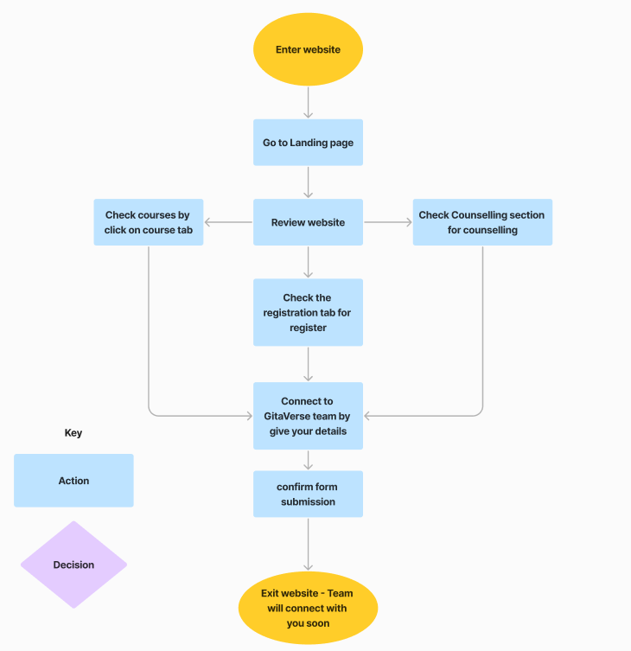

**Figure 7.1.1 GitaVerse - DFD**

**7.2 Development Environment Setup**

For frontend, we utilized Node.js, React JS, and Vite JS, while Express.js and MongoDB were chosen for backend development. This setup streamlined development and ensured compatibility.

**7.3 Data Models and Database Design**

ER Diagrams guided the structuring of data entities, and MongoDB was selected for its flexibility. The database schema accommodates user, course, and lesson data, optimized for efficiency.

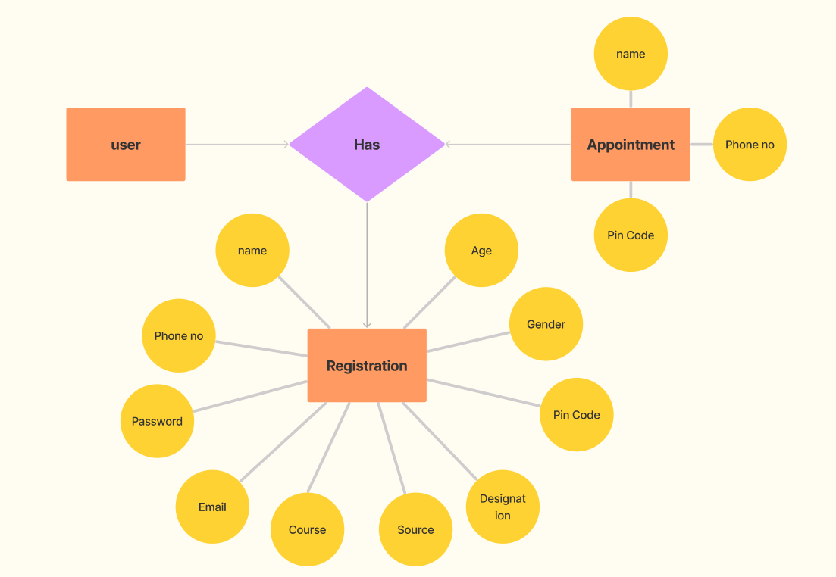

**Figure 7.3.1 GitaVerse – (ER Diagram)**

**CHAPTER 8**

**RESULTS AND EVALUATION**

**8.1 Presentation of Project Outcomes**

**Figure 8.1.1 Project Outcomes**

**8.2 Interpretation of Results**

The outcomes achieved by GitaVerse closely align with its project objectives, showcasing a successful endeavour in bridging Vedic wisdom with modern life. Through the integration of Bhagavad Gita teachings with science and thematic courses, GitaVerse has empowered users with practical insights for personal growth. The establishment of an E-Gurukul for children and efforts to foster cultural awareness further reinforce its commitment to holistic development. Positive feedback and engagement metrics affirm GitaVerse's effectiveness in providing accessible spiritual education globally.

**8.3 Limitations:**

●**Cultural Sensitivity:** Adapting content to diverse cultural backgrounds may pose challenges.

●**Limited Interactivity:** Providing hands-on experiences, especially in personal development camps, may be constrained.

●**Technology Barriers:** Accessibility issues for individuals lacking internet connectivity or compatible devices.

●**Content Updates:** Consistent updates are essential, potentially requiring continuous effort and resources.

●**Engagement Challenges:** Ensuring sustained participation from individuals’ overtime may present difficulties.

**8.4 The Future Scope of the Project:**

**1.Continuous Enrichment:** Regular updates to keep content relevant and insightful.

**2.Tech Advancements:** Integration of new technologies for an enhanced user experience.

**3.Global Alliances:** Partnerships with institutions for broader reach and enriched content.

**4.Specialised Offerings:** Introduction of targeted courses and workshops for diverse interests.

**5.Community Building:** Fostering a vibrant online community through discussions and collaboration.

**6.Academic Contribution:** Encouraging research and publications in the intersection of Vedic wisdom and modern understanding.

**7.Innovative Learning:** Exploring creative approaches for effective character development and holistic education.

**CHAPTER 9**

**CONCLUSION**

GitaVerse embodies a transformative journey, bridging Vedic wisdom with contemporary life. While navigating limitations, its commitment to enriching global education and well-being remains steadfast. As a dynamic platform, GitaVerse's future lies in adaptive growth, technological evolution, and a lasting impact on individuals worldwide.

**References**

[1] GitaQuest. [https://gitaquest.in/](%20https://gitaquest.in/)

[2] Veducation World  [https://www.veducation.world/](%20https://www.veducation.world/)

[3] Save Values. <https://savevalues.in/>

[4] NIH <https://www.ncbi.nlm.nih.gov/pmc/articles/PMC2603047/>

**APPENDICES**

**GitHub Link: -** [**https://github.com/dee161/Gitaverse_Project**](https://github.com/dee161/Gitaverse_Project)

**Vercel Host Link: -** [**https://gitaverse-project.vercel.app/**](https://gitaverse-project.vercel.app/)